Bernard Wong

G00341962@gmit.ie

Abstract

A design document for the 2D mobile game [Dash N Slash].

Dash n slash

Mobile Applications Development 3 Project

Table of Contents

Game Overview 2

Concept: 2

Genre: 2

Target audience: 2

Platform: 2

Gameplay and Mechanics 3

Gameplay: 3

Mechanics: 4

Interface 4

Visual System 4

Control System 4

Audio System 5

Game Plot 5

Game Art 5

Test Plan 11

Menu Test: 11

Mechanic Test: 12

Remarks 12

References 13

# Game Overview

## Concept:

The user plays as a classic stick figure swordsman who is slashing his way to survive 10 levels of minions and a boss.

## Genre:

Platform arena fighting game.

## Target audience:

3 years old and above.

## Platform:

Mobile phones.

# Gameplay and Mechanics

## Gameplay:

* Objectives:
  + Slash down enemies on the platforms.
  + Avoid depleting health or falling down the edge of the platforms.

The objectives are simple to understand. For every level there are several enemies to defeat. Eliminate all enemies on the level to proceed to the next level. Avoid taking too much damage or falling off the playable area to prevent the death of the character.

* Gameplay flow:
  + Enemy minions spawn on each level except the last level.
  + For every level, the number of small minions will increase.
  + When player proceed to 3rd, 6th and 9th level, the player will have to fight against much bigger minions. (Small minions do not spawn in these levels)
  + At the last level, the player will have to fight against and defeat the boss to win the game.
  + At any point of the game the player health bar gets depleted or fall off the edge of the platforms, the player gets a game over and start again from the first level.

The gameplay is the definition of this game. The difficulty increases as the player progress to higher levels. In level 1, 2, 4, 5, 7, 8 only will spawn small minions and the higher the level, the amount of the small minions increase. On 3rd/ 6th/ 9th level, the enemy consist of 2/ 3/ 4 bigger minions to change the pace and the environment of the game. On the last level, the player must face against the final boss to win the game. I decided to let player start over from the beginning when the game is lost because it only had 10 levels, abusing human psychology emotions, the frustration of starting over while so close to winning will let the players want to win the game more.

## Mechanics:

* Movement
  + The player can move either left or right and jump vertically.

The game movements are straightforward and simple as it is only a 2-dimensional game.

* Combat
  + Every minion, the boss and the player each has a health bar.
  + Different types of enemy will deal different amount of damage.
  + The player only deals a constant amount of damage per slash.
  + An enemy is eliminated when its health bar is depleted.
  + After taking damage, the player will have a knockback effect and become immune to damage for half a second.
  + Enemy will try to knock the player off the platform.

Health bar are the essentials for fighting games. Considering the harder the higher the level, big minions will hit harder than small minions, the player only deals a constant amount of damage, but enemy amount increases also means increase difficulty.

I also want to remind the players that minions and boss are not the only threat preventing them from winning the game, so while players took damage, they got knockback and potentially will fall off from the edge of the platforms.

Once the level is cleared, the player need to go to a portal on the right side of the platform and dash to another level.

# Interface

## Visual System

* Heads-Up Display (HUD)
  + Health bar
  + Current level
  + Boss health bar at level 10
  + Setting button to pause game and open menu

## Control System

* 2 buttons on the bottom left side of the screen for left and right movements.
* 1 big button on the bottom right side of the screen for the slash movement.
* 1 smaller button on the top right of the slash button for the jump movement.

## Audio System

* Hurt
  + Occurs when an enemy damaged the player.
* Damage
  + Occurs when the player damaged the enemy.
  + Different types of enemy will emit different damage sound.
* Slash
  + Occurs when the player is swinging/slashing with the sword.

# Game Plot

A swordsman got cursed by an evil wizard and got thrown into another dimension where he constantly fights his way through against the wizard’s minions and challenge the wizard himself to break the curse.

# Game Art

The graphics of the game is as simple as it gets. The classic stickman figures for all the characters in the game and simple plank for the platform. These are all only the sketches of my idea:

1. Main menu

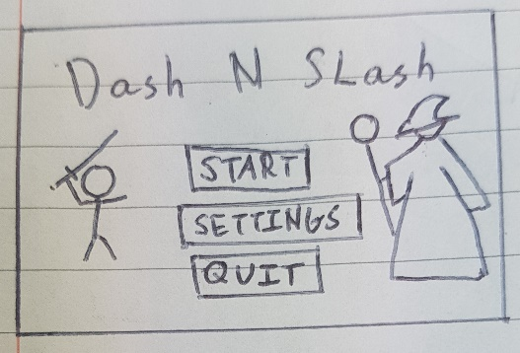

Simple main menu with 3 buttons (Start game, settings and quit game). Title on the top, main protagonist on the left taunting the villain wizard on the right.

1. Scene background

A dark moody background as it is another dimensional space (not earth). Probably a bunch a volcano on the back and larva on the bottom to express hazardous environment.

1. The player and animations
   1. Model

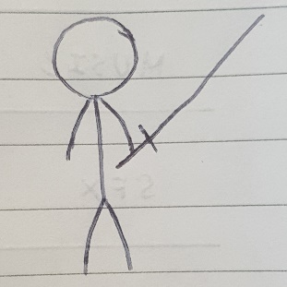

* 1. Jumping

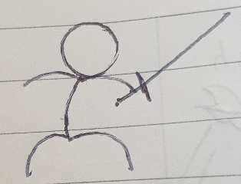

* 1. Slashing

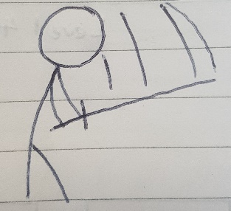

A simple stickman figure represents the main protagonist of the game. The walking animations is just swinging the hands while swapping leg positions. When it took damage, the stickman flashes a red colour to indicate health is deducted and flashing white and black to indicate immunity for half a second.

1. Small minions and animations
   1. Model

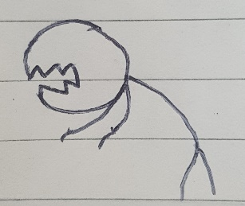

* 1. Attacking

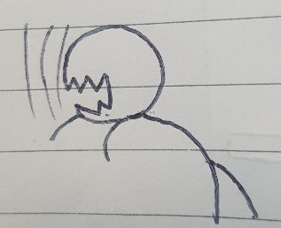

* 1. Eliminated

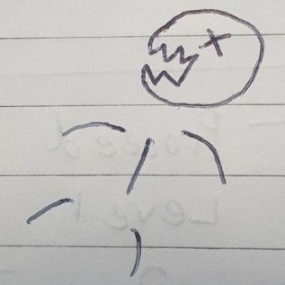

A ghoul like stick figure that use claws to attack. Dismembered after its life is depleted.

1. Big minions and animations
   1. Model

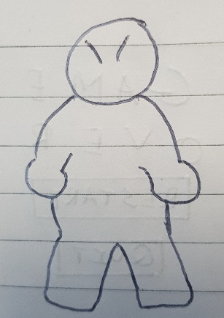

* 1. Attacking

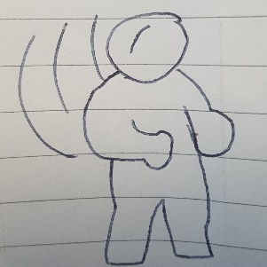

* 1. Eliminated

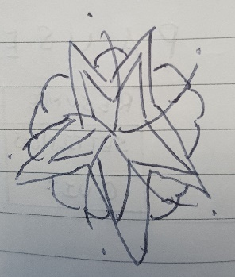

Big minions are much taller and bulkier, hence no stick like body figure. It uses its fist to swing its punch and when it dies, it will explode.

1. Boss and animations
   1. Model

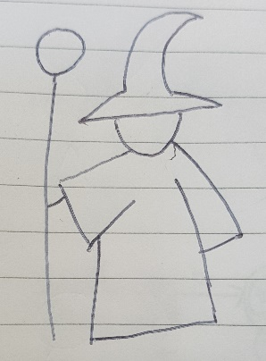

* 1. Attacking

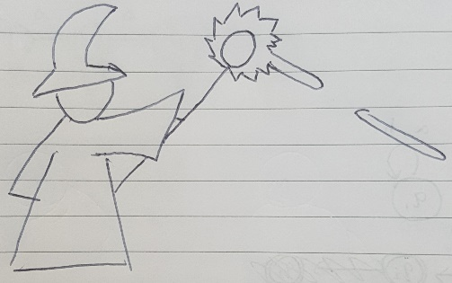

* 1. Eliminated

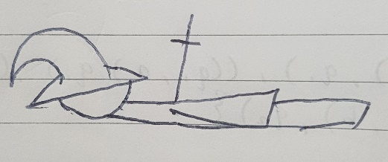

The boss is the evil wizard that cursed the main protagonist of the game. He wears a typical wizard hat and holding a staff. He shoots lasers as his attack animation and when he dies, the Game Over screen pops up.

1. HUD

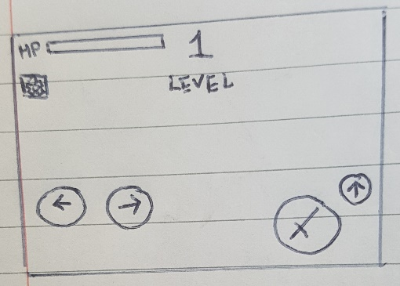

The Head-On Display has the players health bar on the top left side, a pause button on the bottom of it, a level indicator on the top middle, and 4 buttons on the bottom of the screen. The two bottom buttons are left and right movement buttons placing on the left side and on the right side are the attack/slash button and a jump button.

1. Level transition screen

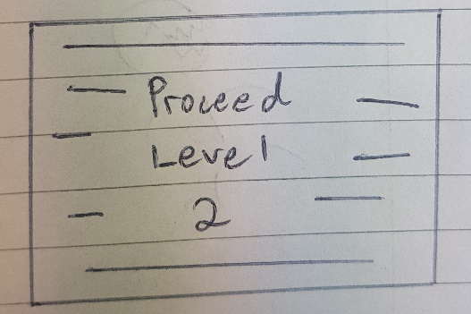

After the player cleared a level, the player will then enter the portal on the right of the platform and proceed to the next level. The transition screen will display the level and multiple white light dashing from right to left to mimic a fast travel transition effect.

1. Level platforms
   1. Level 1, 2 and 3

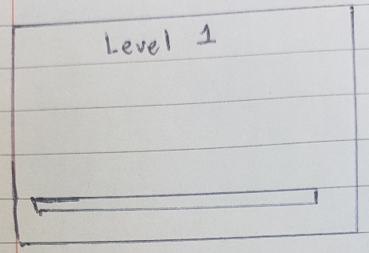

* 1. Level 4, 5 and 6

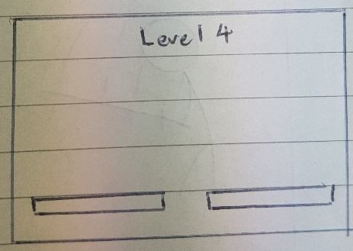

* 1. Level 7, 8 and 9

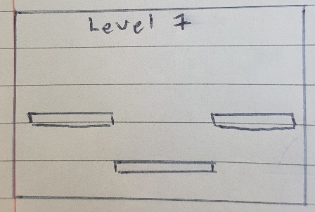

* 1. Level 10

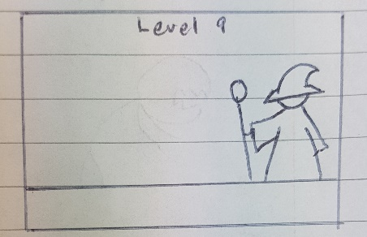

For every 3 levels, the arena environment changes to change the gameplay and mood of the game. For the last level there is no gaps on the floor as the battle against the wizard is hard enough.

1. Pause screen and Setting screen

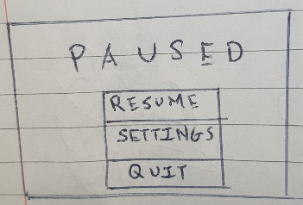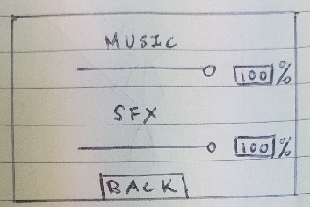

The pause screen will pause the game and let users to choose 3 options. Resume button to resume the game, settings button will open the settings menu, quit button will quit the game. The setting screens contains 2 bars to control the volume of music and sound effects.

1. Game over screen

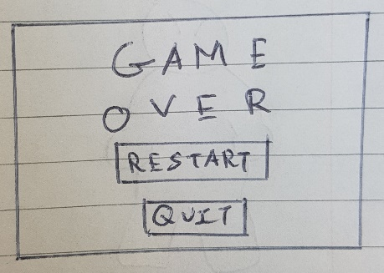

When the player loses the game by either fall off the edge of the platform or the health bar is depleted, the game over screen will pop up and let users to either restart the game or quit.

1. Victory screen

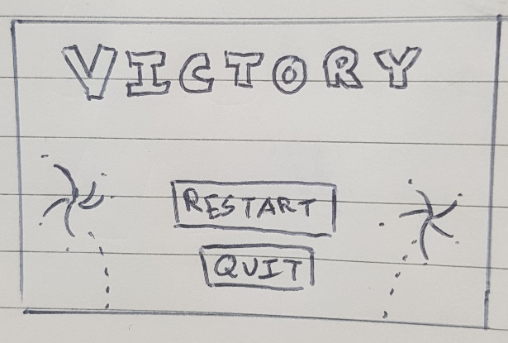

When the player defeats the wizard, the victory screen pops up with the same options as the game over screen. There are fireworks constantly shooting and exploding in the background.

# Test Plan

There are some test cases that can be design during pre-development phase:

## Menu Test:

|  |  |  |
| --- | --- | --- |
| Prerequisites | Event | Expected Result |
| On Menu screen | Tap start button | Game starts |
| On Menu screen | Tap setting button | Transition to setting menu |
| On Menu screen | Tap quit button | Quit game |
| On Setting screen | Slide music bar | Music volume gets smaller or bigger |
| On Setting screen | Slide SFX bar | Sound effect volume gets smaller or bigger |
| On Setting screen | Tap back button | Back to previous menu |
| On Pause screen | Tap resume button | Resume the game |
| On Pause screen | Tap setting button | Transition to setting menu |
| On Pause screen | Tap quit button | Quit game |
| On Victory screen | Tap restart button | Restart game |
| On Victory screen | Tap quit button | Quit game |
| On Game Over screen | Tap restart button | Restart game |
| On Game Over screen | Tap quit button | Quit game |

## Mechanic Test:

|  |  |  |
| --- | --- | --- |
| Prerequisites | Event | Expected Result |
| In any level | Press left button | Player walk left |
| In any level | Press right button | Player walk right |
| In any level | Press attack/slash button | Player swing sword |
| In any level | Press jump button | Player jump |
| In any level | Player’s health depleted | Game over screen pops up |
| In any level except last level | Player fell off the edge of the platform | Game over screen pops up |
| In any level | Player hit any enemy | Enemy health bar decrease, if depleted, eliminated |
| In last level | Player hit the wizard | If wizard health bar depleted, victory screen pops up |
| In any level | Player cleared the level | A portal appears on the right |
| In any level | Player got damaged | Health decreased, flash a red colour and flash black and white for half a second |

# Remarks

This game has an easy to understand concept, friendly to all people and not difficult to implement. Suitable for people to kill time. Some of the details could not be determine during design phase like the amount of damage the main protagonist deals, number of minions, the jumping height etc as these factors can decide the balance and pace of the game.

The critical asset of the game is that if the player loses the game, the player must start the game all over again. This made people frustrated and if the player made it very close to the end but loses the game, most of the player will try again and again until they succeed.

# References

* GitHub link

[https://github.com/BernardWong97/Mobile-App-Dev-3]

* Research for the design document [https://github.com/BernardWong97/Mobile-App-Dev-3/blob/master/Project%20Research.docx]
* List of fighting games [https://en.wikipedia.org/wiki/List_of_fighting_games]
* Super Smash Bros
  + Wiki [https://en.wikipedia.org/wiki/Super_Smash_Bros.]
  + Mechanics and Gameplay [https://www.eurogamer.net/articles/2019-01-28-super-smash-bros-ultimate-tips-6005]
* Street Fighter
  + Wiki [https://en.wikipedia.org/wiki/Street_Fighter]
* Mortal Kombat
  + Wiki [https://en.wikipedia.org/wiki/Mortal_Kombat]
* Digimon Rumble Arena
  + Wiki [https://en.wikipedia.org/wiki/Digimon_Rumble_Arena]
  + Gameplay [https://www.youtube.com/watch?v=IddF4QN7vJw]